High Resolution Wind Speed Encoder

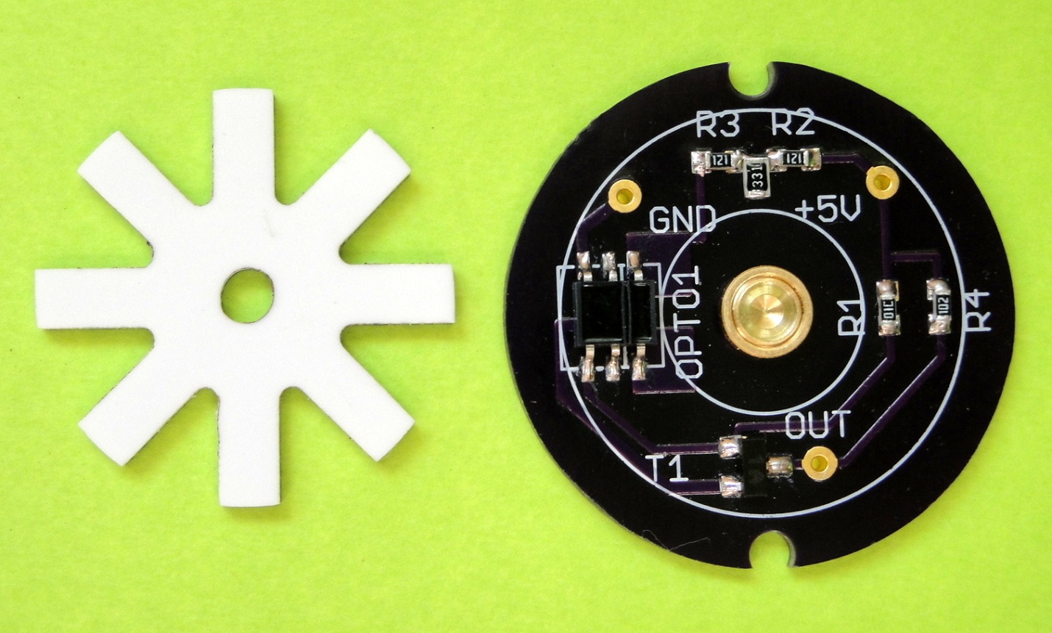

# Description

Based on a reflective optical interrupt device the sensors provides an eight fold increase in resolution for wind speed measurements compared to a basic reed switch device. This allows for a reduced measure interval, thus enabling the capture of short period wind gusts and airspeeds down to 0.5 Mph. The sensor asserts no drag on the anemometer cups, which, coupled with the sapphire bearing, makes for a virtually drag-free setup.

# Applications

* High definition/resolution wind speed monitoring & recording
* Capturing of micro gusts
* Capturing of very low wind-speeds
* DIY and custom weather stations

# Features

* Solid state
* Drag free
* Eight times the resolution compared to standard sensors
* Interfaces direct to microcontroller inputs
* No false readings due to reed switch bounce or magnetic fatigue
* Built in Hysteresis

# Electrical specifications

* Input voltage nominal 5V, maximum 5.5V
* Do not short output to ground
* Do not short output to +5V
* Required measure input impedance > 1K
* Current consumption 20 to 27mA @5V

|  |  |  |  |  |
| --- | --- | --- | --- | --- |
| Name | Symbol on PCB | Description | Condition | |
|  | | | | |
| Ground | GND | Ground reference | -- | |
| Power | +5V | Regulated power input | 5V +/- 5% , less than 50mv noise | |
| Output Signal | OUT | 8 pulses per revolution | Low <0.15V, | High <3.5>3V |

# The device can sink and source 1.5ma. It is intended to be connected to a high impedance micro processor input through a series resistor and transorb or shottky diode for transient protection of the input on long cable runs.

# Mechanical specifications

* PCB dimension: Rround, 1” diameter
* Sensor to rotor distance 1.5mm +/- 10%

+5V regulated supply

System Ground

Output Signal

Note on revolution to wind speed calculations

When used with Inspeeds anemometer cups, 60 revolutions per minute equals 2.5MPH

When used with Davis Instruments cups , 60 RPM equals 2.25 MPH